IMAP Pilot Info System User Guide

Document Id.:
Approved by:
Checked by:

Table of Contents

1. Summary 3
2. Site Map 4
2.1. Home page 4
2.2. Info and contacts 5
2.3. Geographical data 5
2.4. Standards 8
2.5. Upload 9
2.5.1. Upload monitoring file 10
2.5.2. Search 12
2.5.3. Cancel monitoring file 13
2.5.4. Conformity check 13
2.5.5. Conformity check failed 13
2.5.6. Conformity check successful 14
2.5.7. Validation and publication 14

Summary
The IMAP Pilot Info System (PIS) aims to collect, manage and share data from monitoring programs under the Integrated Monitoring and Assessment Programme of the Mediterranean Sea and Coast and Related Assessment Criteria (IMAP) in the framework of Barcelona Convention.

Site Map

Home page
From the home page of the site it is possible to access to public sections:
- Log in to access private sections
- Info and contacts
- Geographical data
- Standards
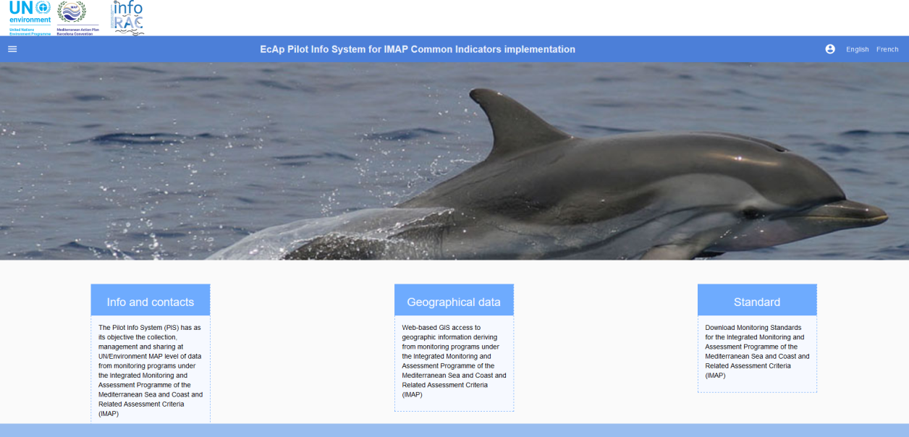
Figure 1: Site home page
To log in, click on the button at the top right (Account ), enter username and password and press "LOGIN".
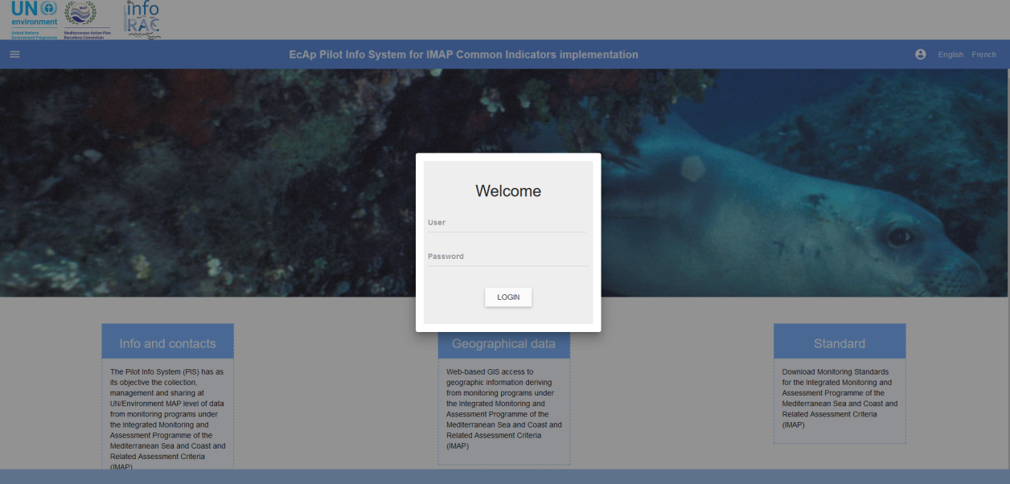
Figure 2: Login
After login, the home page will be updated with new sections depending on the logged user profile:
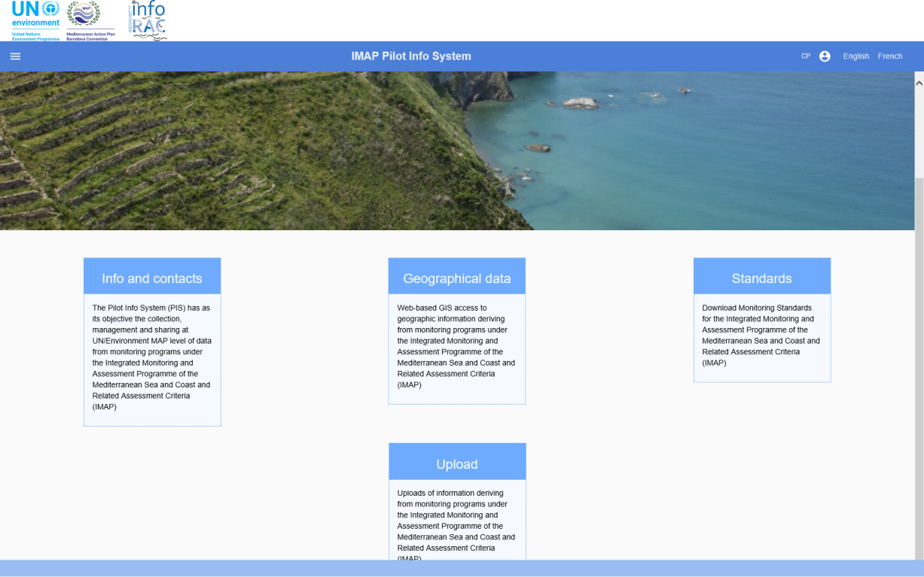
Figure 3: Homepage after Login

Info and contacts
The "Info and contacts" section contains useful references to contact the site managers.
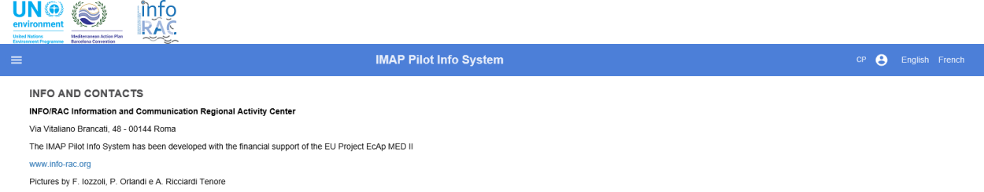
Figure 4: Info and contacts page

Geographical data
This section contains the functionalities to access published data, by an anonymous user, through a WEBGIS interface.
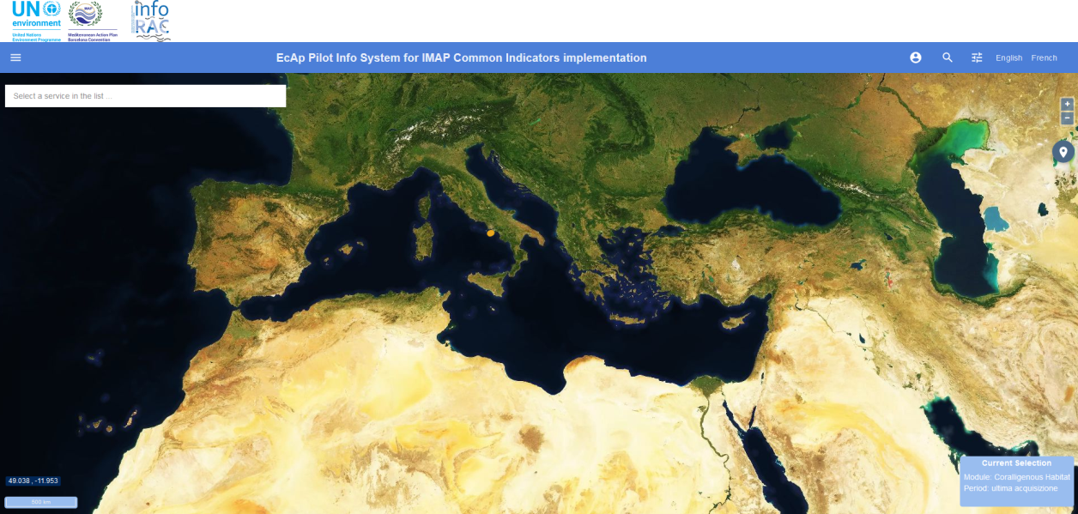
Figure 5: WEBGIS interface
GIS tools available are:
- Zoom / Pan, allows to change the extent of the map;
- Location search, allows to zoom the map on a location;
- Active mode allow you to:
  - 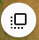 Draw the polygon and calculate the area
  - Draw the line and calculate the length
  - Query stations
  - Keep stations previously queried
- Selection of a service in the list.
The “Filters” tool allows to select:
- A background map;
- The monitored data layer (module type);
- The monitoring period (time interval);
- The last data acquisition;
- Transparency;
- Stations export;
- The possibility of creating a bookmark.
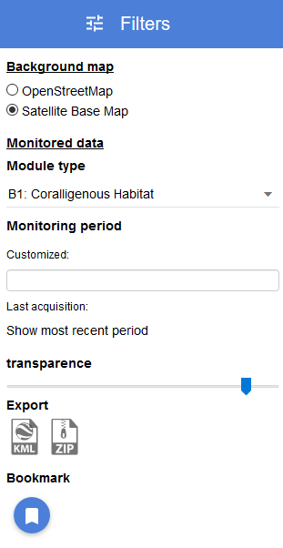
Figure 6: Filters tool
Monitored stations are displayed on the map as points.
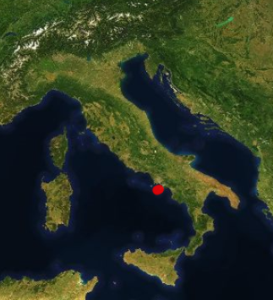
Figure 7: Station point
Selecting a station with the mouse, the consultation page of the relative measures is shown:
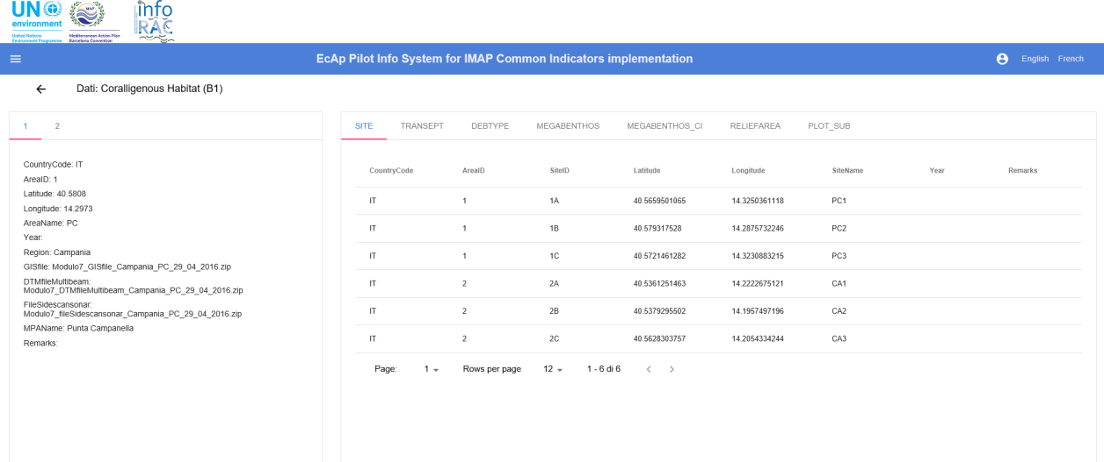
Figure 8: Measures detail page

Standards
The “Standards” section allows to a simple user to:
- View the list of information standards;
- Download an information standard in Excel format;
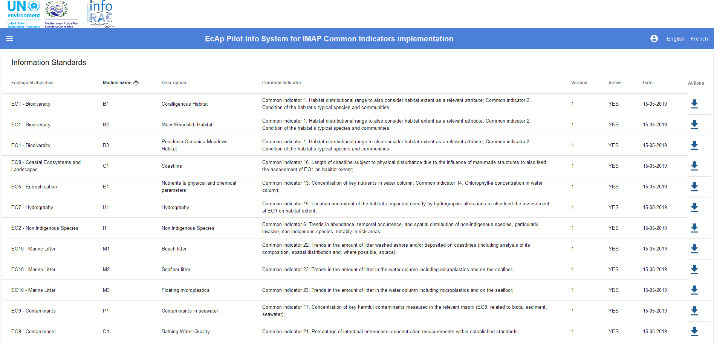
Figure 9: Standards section (simple user)
For example, the user can download “EO1 - Biodiversity B1 Coralligenous Habitat” standard by clicking on the arrow at the end of the row.
Figure 10: Download Standard
Clicking on “Information Standard” the user can Open, Save or Save as the Excel document.
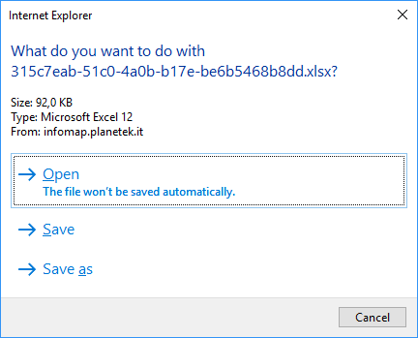
Figure 11: Save Standard
Save the document and then open it.
Every standard has sheets (named <DD_sheetname>) explaining how to complete sheets (named <sheetname>) that have to contain the measure data.
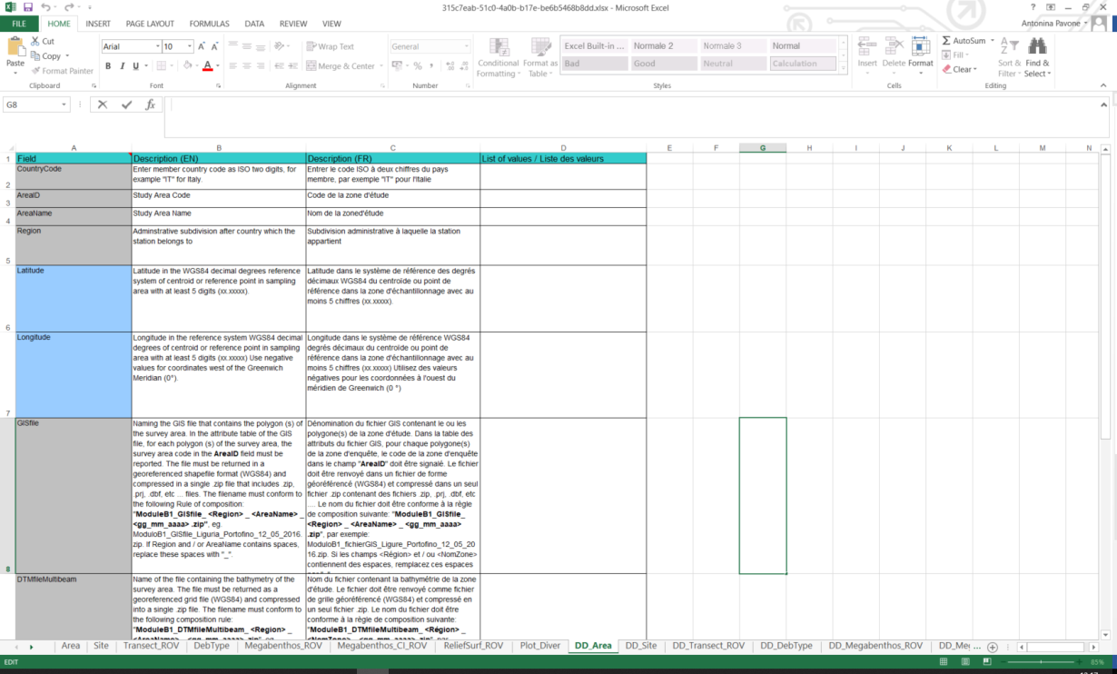
Figure 12: <DD_sheetname>
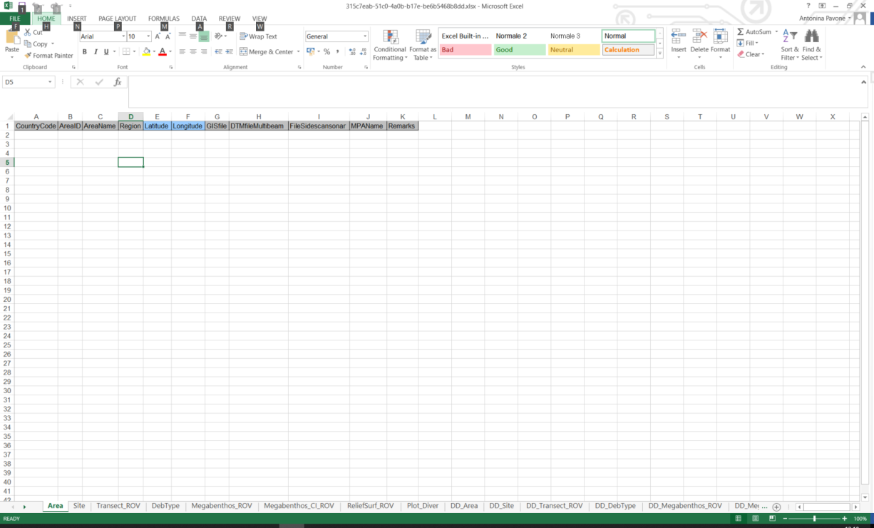
Figure 13: <sheetname>
For example, sheet “DD_Area” is a data dictionary explaining how to insert data into “Area” sheet in the monitoring file to be uploaded.

Upload
The upload section allows to upload, verify, validate and publish the monitoring files. The uploaded monitoring files follow a predetermined workflow. Each loaded file will be subject to:
- Conformity check, i.e. verification of compliance with the rules to which the data must be subjected (excel file)
- Validation, i.e. check of administrator or supervisor
- Publication, i.e. the data are loaded into database, published and accessible via WEBGIS interface.
Workflow states are:
- Draft: when file is just loaded;
- Compliant: when file passes the conformity check;
- Not compliant: when the conformity check gives a negative result;
- Validated: when the user makes file valid;
- Not Validated: when the user considers the data invalid;
- Published: when the user decides to make data public;
- Canceled: when the user deletes file from the workflow;

Upload monitoring file
To upload a monitoring file press the button on the bottom right.
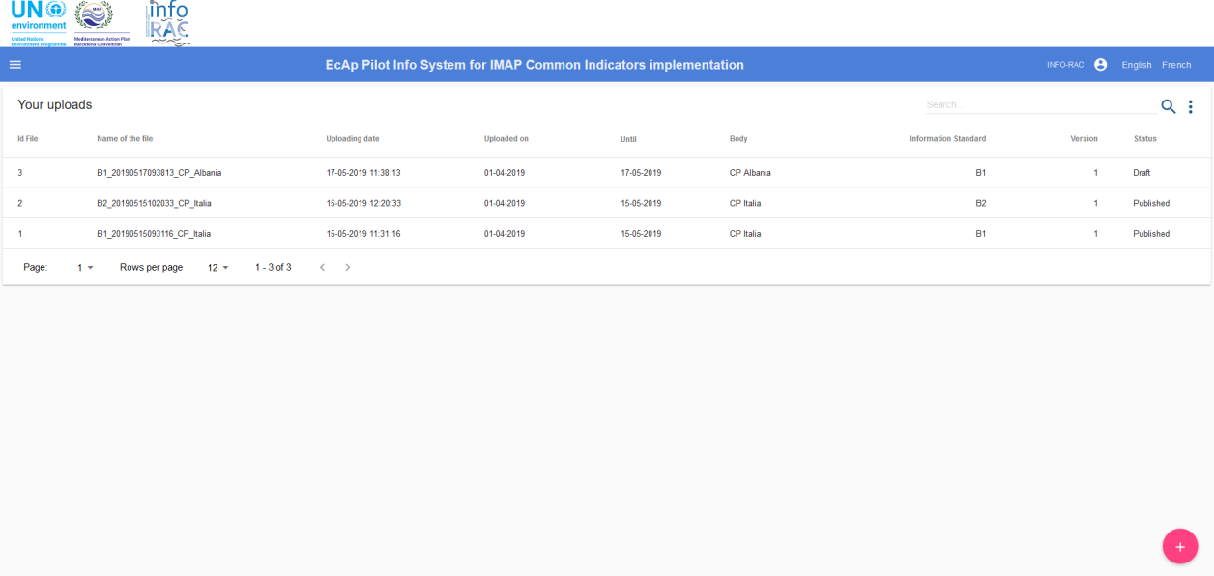
Figure 14: Uploaded files list
In the new upload window (1/3) enter the following information:
- Select sampling period: period in which the monitoring was carried out;
Figure 15: Select sampling period (1)

Figure 16: Select sampling period (2)
- Standard module: the name of the standard module filled in with data;
Figure 17: Select the standard module
Press the "CLOSE" button to cancel or "CONTINUE" to continue.
In the next upload window (2/3), the Excel file can be loaded in one of the following ways:
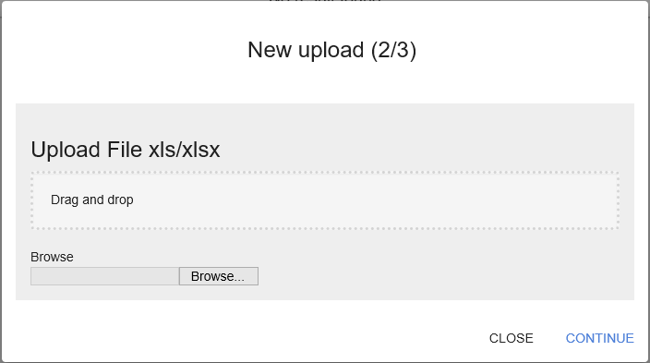
Figure 18: File upload (2/3)
- Drag & drop: upload the file by dragging it into the appropriate section
- Choose file: select the file from the explore window
Once the file has been chosen, press "Upload" to send the data to the server.
Figure 19: File upload (2/3)
Press the "CLOSE" button to cancel or "CONTINUE" to continue.
In the next upload window (3/3) it is possible to load attachments in one of the following ways:
- Drag & drop: load the file by dragging it into the appropriate section
- Choose file: select the file from the explore window
It is possible to upload one or more attachments. Once the files have been selected, press "UPLOAD" to send the data to the server.
Figure 20: File upload (3/3)
Press the "FINISH" button to complete or "CLOSE" to interrupt all file loading activity.
The uploaded file will take in “Draft” status and will appear in the uploaded file list.

Search
In the “Upload” section it is possible to carry out both a textual search and an advanced search within the set of uploaded files.
Figure 21: Search and Advanced search
The Text Search allows to search for a text within all uploaded files (not their content).
The advanced search allows to filter on:
- Acquisition time interval
- Loading time interval
- Standard
- File status (Canceled, Compliant, Draft, , ...)
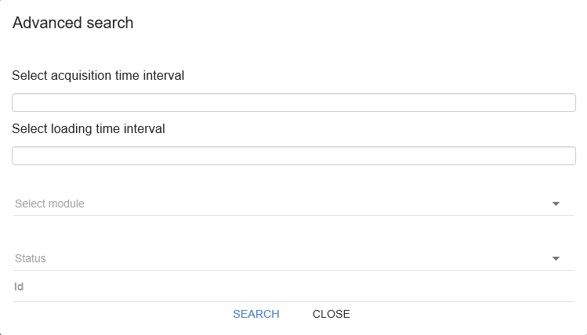
Figure 22: Advanced search

Cancel monitoring file
If the loaded file is in the “Draft” status, it can be removed from workflow. To do this, press the “CANCEL UPLOAD” option on the details page of the loaded file.
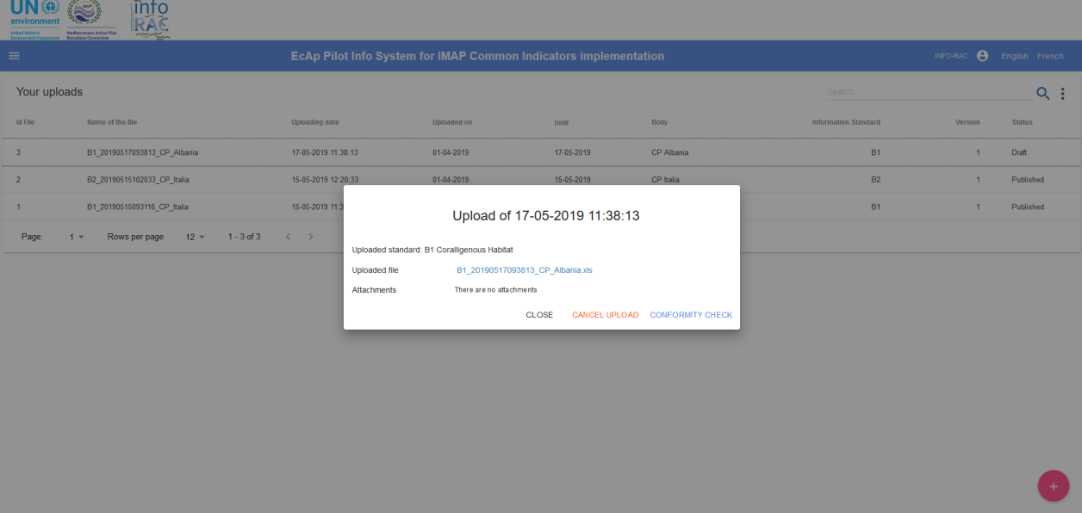
Figure 23: Cancel monitoring file

Conformity check
To check the conformity of a file (i.e. it respects the rules defined in the information standard) it is necessary to click - from the list of uploads - on the name of the file being in “Draft” status and press the “CONFORMITY CHECK”.
Conformity check can give two results:
- Conformity check failed (see next paragraph)
- Conformity check is successful: loaded file changes from “Draft” to “Compliant” status

Conformity check failed
If conformity check fails, the system shows an error message.
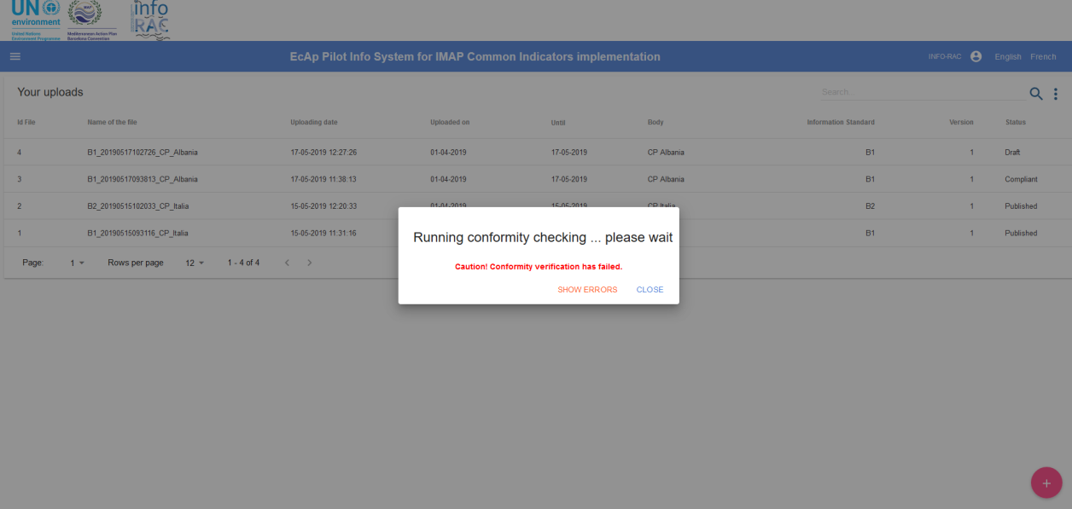
Figure 24: Conformity check error message
By pressing the "SHOW ERRORS" button, it is possible to download an Excel spreadsheet containing all the errors that have to be resolved to pass the conformity check.
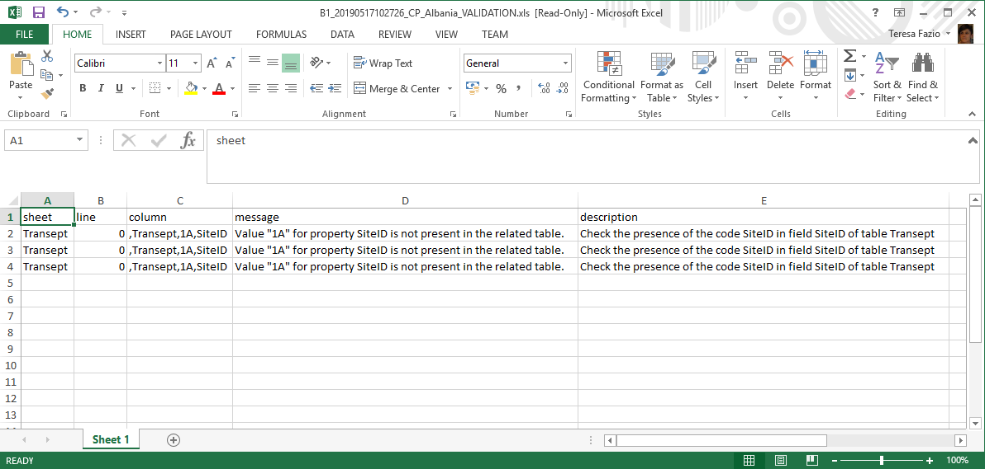
Figure 25: Spreadsheet of conformity errors
The excel sheet contains indications on the errors to be managed: code and error message as well as line, column and sheet from which the error derives.

Conformity check successful
In this case the status of the loaded file changes to “Compliant”.

Validation and publication
Files in “Compliant” status can be validated and subsequently published.
To validate it is necessary to click on the file and press the "VALID" button.
In the same way it is possible to make it "INVALID".
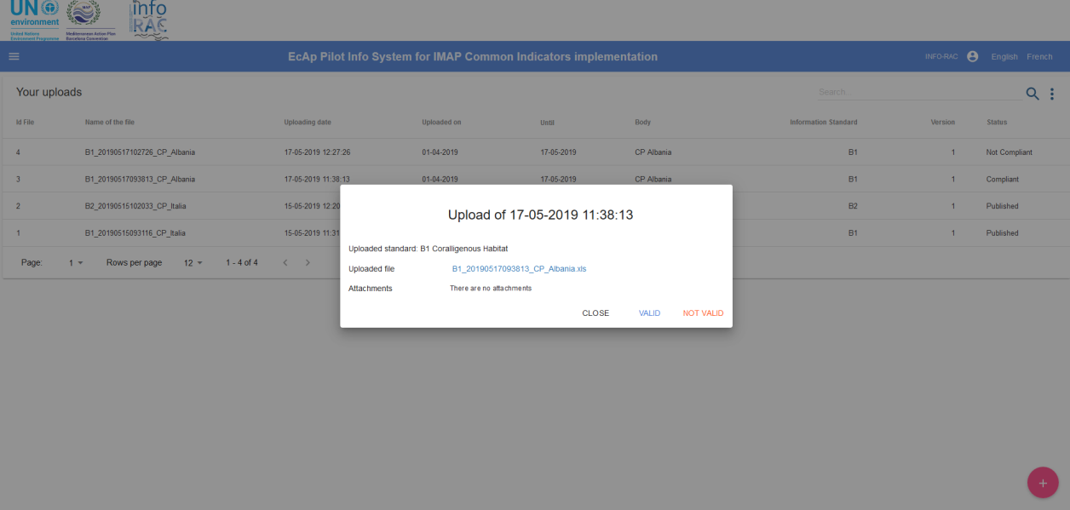
Figure 26: Validation
The monitoring information contained in a previously validated file can be published using the “PUBLISH” button.
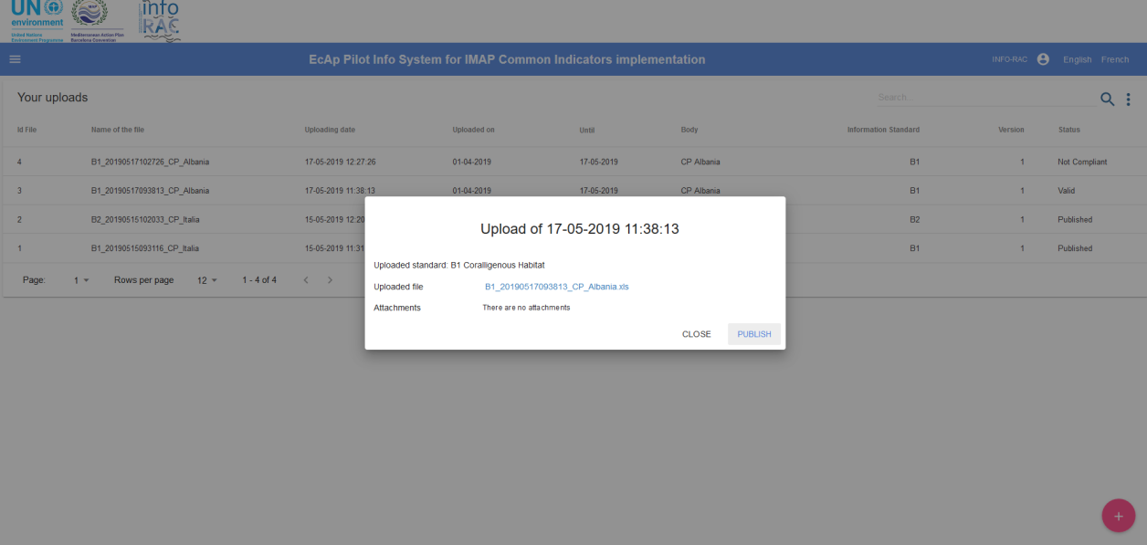
Figure 27: Publishing
This operation involves loading of the monitoring information into database.

